- Self-balancing robot-

(Arduino project)

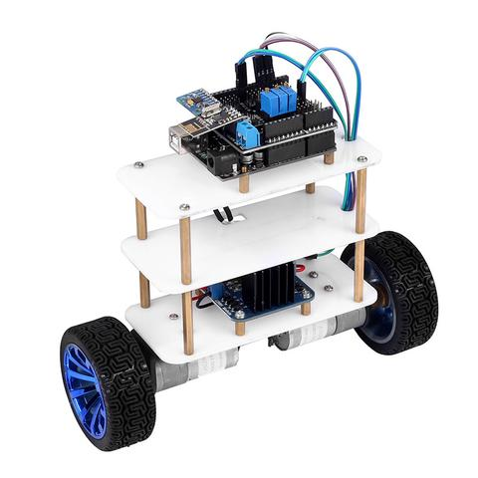

Description:

After being inspired by self-balancing scooter from Segway,

I wanted to build something similar. Thinking for while I decided

To build a self-balancing robot using Arduino.

How does balancing work?

To keep the robot balance, the motors must counteract the robot falling. This action requires feedback and correcting elements. The feedback element is the MPU6050 gyroscope + accelerometer, which gives both acceleration and rotation in all three axes. The Arduino uses this to know the current orientation of the robot. The correcting element is the motor and wheel combination.

Selecting the Parts for the Bot:

* Arduino UNO
* Geared 2 DC motors (yellow coloured)
* L298n motor driver module
* MPU6050
* Pair of wheels
* 7.4 V Li-ion battery
* Connecting wires
* Body

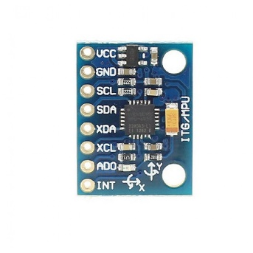 

MPU6050 7.4 V Li-ion

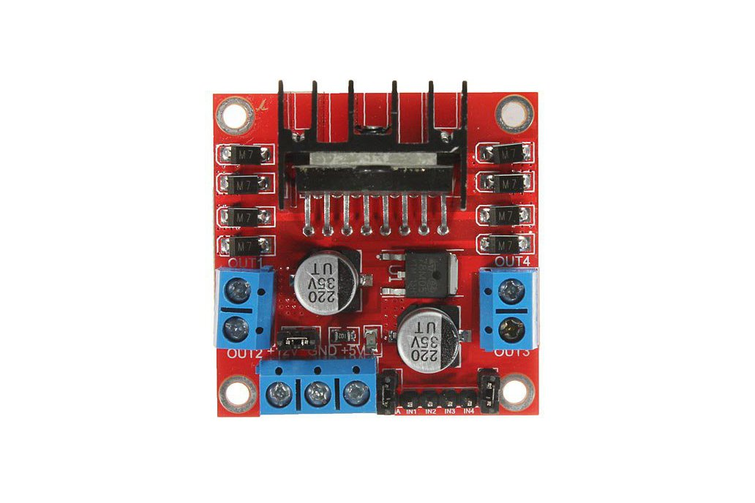 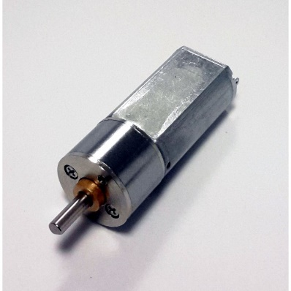

L298n motor driver module Geared 2 DC motors

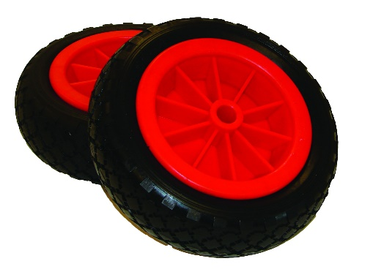

* Pair of wheels

Circuit diagram:

